**Team 5 Project: Tarot Fortune Teller Introduction:**

We decided to do a fortune teller project. The goal of this project is to go through a library of tarot cards and pick 3 cards to foretell the users, past, present, and future. Each card will have an upside-down variant and a right side up one, as well as 3 sub-variants for each.

This will come out to be a total of 264 readings.

**Project Organization:**

|  |  |  |
| --- | --- | --- |
| Name | Role | Description |
| Jose Ramirez | Designer/Organizer | Create layouts and organizes meetings |
| Joseph Jacobs | Organizer/Tester | Organizes meetings. Divides work appropriately amongst the group and test project. |
| Ian Schaak | Programmer/Designer | Makes content for the game and assists in programming |
| Olivia Stanich | Programmer | Heads up programming. Getting the core idea, and the product made |

**Risk Analysis:**

|  |  |
| --- | --- |
| List of Risks | Description |
| Late Delivery | The project isn’t turned in by the designated due date. |
| Cloud Software Equipment Failure | The web-based software we rely on malfunctions, resulting in corrupted files. |
| Team Members Not Available | There could be many different reasons why we could be unable to work on our projects. From personal reasons to emergencies, it is always a risk that could happen. |
| Project Idea Changes | Our team has decided on a tarot fortune telling game. |
| Hardware Equipment Failure | A team member's personal device could experience a critical failure, making it unusable. |
| Presentation Can’t Be Completed | The presentation is unable to be finished by the due date. |
| Local Software Equipment Failure | The software used to build the project fails, resulting in either the software unable to be used or the project files being lost. |
| Can’t Meet Outside of Class | The team is unable to find time outside of class to meet together. Our group members all likely have jobs and outside responsibilities. |
| Proper Graphics Aren’t Made | The visual graphics in the final project could lack quality. For instance, the animation appears awkward, the color scheme lacks |

|  |  |
| --- | --- |
|  | harmony, and the images do not integrate seamlessly into the game. |
| Coding Becomes Too Much for Allowed Time | Some of the code functionality isn’t completed by the designated due date. |
| Debugging Can’t Be Completed | Some of the code errors can’t be solved by the designated due date. |

**Risk Analysis**

|  |  |  |
| --- | --- | --- |
| Risk | Probability | Effect |
| Late Delivery | Low: The due date is very clear in the class syllabus. and we’ve known it since the start of the class. | Catastrophic: We will all receive a 0 on the project. |
| Cloud Software Equipment Failure | Low: Sites like GitHub and Google Drive will most likely be secure place to contain out code. | Catastrophic: We will lose all of our files online. |
| Team Members Not Available | Low: There is a low chance one of us will have an accident, however it’s still a possibility. Sometimes this cannot be avoided. | Serious: This will slow down the work on our project by quite a bit. |
| Project Idea Changes | Low: our group has decided on a tarot fortune telling game. | Serious: This will set us back to square one. |
| Hardware Equipment Failure | Moderate: Our personal devices could malfunction. This is always a serous possibility. | Serious: This will leave one of our team members without the ability to work on the project. |

|  |  |  |
| --- | --- | --- |
| Presentation Can’t Be Completed | Moderate: Finishing the actual game is the top priority, so we might run out of time for the presentation. | Serious: This could hurt our grade on the final project. |
| Local Software Equipment Failure | Moderate: The files or applications we use might run into an error or stop working. | Tolerable: Smaller files can be recreated, and applications can be redownloaded. Plus, we’ll upload files for the project to GitHub. |
| Can’t Meet Outside of Class | Moderate: Troublesome Weather, technology issues, work, or other plans may lead for the group being unable to meet outside of plans | Tolerable: We can meet again on a different date to catch up on what we originally planned for the meeting. |
| Proper Graphics Aren’t Made | Moderate: We could face time constraints that might prevent us from achieving a high-quality appearance for everything. | Tolerable: The game doesn’t need to look like it was made by a professional company. |
| Coding Becomes Too Much for Allowed Time | High: There is a ton of functionality that must be completed, and the time to complete all of it is small. | Serious: Depending on what we don’t get finished, this could seriously hurt our grade. |
| Debugging Can’t Be Completed | High: Testing everything in the game will take time that we might not have. | Tolerable: If there isn't anything game breaking, our grade should still be fine. |

**Risk Planning**

Schedule Risk: For any potential schedule risks, Team 5 will establish a sensible project timeline and ensure clear understanding among all players. Progress will be closely monitored against the planned schedule throughout the project, and corrective measures implemented promptly if any possible issues occur.

Technical Risk: To tackle technical risks, Team 5 will ensure we have the right technical skills and resources in place to carry out the project effectively. We'll also conduct thorough testing and quality assurance to prevent any technical glitches.

Resource Risk: We'll allocate resources according to the project's requirements, regularly monitor them, and adjust as needed to ensure successful project completion.

Scope Risk: Team 5 will establish a clear project scope and ensure all team members understand it. A designated manager will handle any scope changes, communicating them promptly to the team.

Financial Risk: To handle financial risks, Team 5 will establish a practical project budget and track actual costs against it. We'll ensure clear financial reporting and accountability measures, keeping all parties informed of the project's financial status. If any financial risks emerge, we'll promptly take corrective action to prevent further losses.

**Hardware and Software Requirements**

# Hardware:

* Windows computer
* Monitor
* Keyboard and mouse

# Software:

* Windows
* 4 gb memory

**Work Breakdown:**

For this project, a lot of it will be content creation. First, we will get some working prototypes, then decide on a visual direction.

Once we get things moving in the right direction with the program, we will do that content creation, making predictions. There are around 264 that we need to make, there is work to split.

After getting all the written content and visual content established, we can test to make sure everything is working fine.

**Data Flow Diagram:**

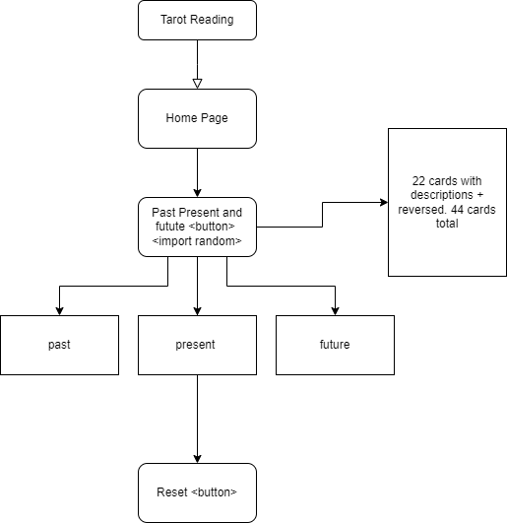

**Project Schedule:**

We are set to meet every week to discuss the project and touch base.

|  |  |  |
| --- | --- | --- |
| Week 1 | Introductions | Getting your head around the idea |
| Week 2 | Work Break Down | Divide work amongst group |
| Week 3 | Work check | Everyone touches base on personal work to understand the overall direction |
| Week 4 | Wrap up Rough Draft | Test a prototype idea with limited capability |
| Week 5 | Work out the kinks | Fix up bugs |
| Week 6 | Busy work | Make all the content that. May need 264 predictions |
| Week 7 | Finalize | Perform final tests on app |
| Week 8 | Submission | Turn in what’s done |

**Monitoring and Reporting Methods:**

We plan on relying on each other. Any issues can be reported to another teammate. We are scheduled to meet weekly, that will also be a time for people to update everyone on their status. If something goes wrong, we have enough redundancies in place to keep us on track.

Discord is what we use to keep in touch and GitHub is where we will be sharing files. Any typed-out work is done on Google’s office system.

**Appendix**

|  |  |  |  |  |  |
| --- | --- | --- | --- | --- | --- |
| **Task#** | **Task** | **Duration** | **Dependencies** | **Description** | **Completed Task** |
| **1** | **Planning** | **3 weeks** | **none** | **Figure out how who and what** | **Completed:**  **All Team Members** |
| **2** | **Implementation** | **3 weeks** | **1** | **Start doing the work to see where we get as we get into it** | **Completed:**  **Joseph/Ian** |
| **3** | **Coding: System** | **2 weeks** | **1,2** | **Program the system to search for the cards and organize them** | **Completed:**  **Olivia** |
| **4** | **Coding: Cards** | **2 weeks** | **1,2** | **Program the memory space for the cards** | **Completed:**  **Olivia** |
| **5** | **Designing** | **2 weeks** | **3,4** | **Design the layout and card artwork** | **Completed:**  **Jose/Ian** |
| **6** | **Testing** | **2 weeks** | **3,4,5** | **Test the app for issues** | **Completed:**  **All Team Members** |
| **7** | **Finalizing** | **1 week** | **6** | **Present as completed project** | **Completed:**  **All Team Members** |